Chapter 1

INTRODUCTION

Much of the information that humans get from the outside world is obtained through sight. Without this facility, visually impaired people suffer inconveniences in their daily and social life. A total loss of eyesight is one of the most serious misfortunes that can befall a person. Our project aims at conveying information about the environment to visually impaired individuals, so that they can exploit a part of the information that sighted people normally use to experience and navigate. Many devices exist to assist visually impaired people for navigation. A number of research institutes and software companies are working on solutions to the problems of determining appropriate navigational information for visually impaired people. From the early 1950's several efforts in the provision of travel aids for visually impaired people have been made. They range from the simple cane to advanced computer based aids. The development of other assisting devices such as Braille electronic reading machine to aid visually impaired people in their everyday life has been very effective. But adequate solutions for navigation assistance for visually impaired have not yet been achieved.
In this paper, we deal with the recognition of a variety of moving objects which may possess a threat to the blind man while navigating. The proposed algorithm is resistant to small illumination changes and also involves a module that reduces effects of camera movement.
ENVIRONMENTAL INTERFACE
PROCESSING
USER INTERFACE

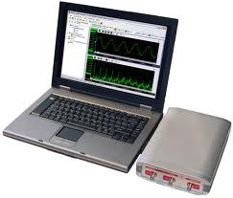


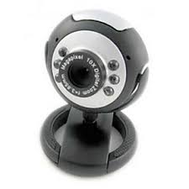

Figure 1.1 Main Components of the proposed system

1.1 Video Stabilization and Key Frame Extraction
Video footage from hand-held camcorders is typically jerky due to small, unwanted camera movements. Removal of those undesired movements requires video stabilization techniques. As its name suggests, video stabilization is the process of generating a compensated video sequence where image motion by the camera's undesirable shake or jiggle is removed. Video stabilization is an important step for many video processing works. It is used in a range of fields including, surveillance, tracking, situational awareness and diverse hand-held video recording devices.
Many methods for video stabilization have been reported over the past few years. Some methods use a global motion model followed by filtering to remove motion related artifacts from video frames. The basic idea of the proposed stabilization algorithm is to first determine the affine image transformations between all neighbouring frames of the video by using a Random Sampling and Consensus (RANSAC) procedure applied to point correspondences between two images. Then the video frames are warped to achieve a stabilized video.
All the frames in the video do not contain important information. Hence, it is not meaningful to analyse all the frames; so we find those frames which contain important information. These frames, containing the important information are called key frames. The key frames must be extracted so as to describe the contents of the video in the later processing stages. After the extraction of important frames, instead of analysing the contents of all video frames, only the key frame images are analysed to give the annotation. The number of frames should not be reduced to an extent that important information is not covered by the key frames. As the key frames are analysed after the key frame extraction process, the algorithm for extraction should not be very complex or time consuming. Each frame is a slight variation of the previous frame.
1.2 Object Detection and Background Subtraction
Detection of moving objects and motion based tracking are important components of many computer vision applications, including activity recognition, traffic monitoring and automotive safety. Detection and motion based tracking of moving objects in a video from a moving camera involves Gaussian mixture model and Kalman filter. The problem of motion based object tracking can be divided into two parts such as detecting moving objects in each frame and associating the detections corresponding to the same object over time. The detection of moving objects uses a background subtraction algorithm based on Gaussian mixture models.
Foreground detection compares the video frame with the background model, and identifies foreground pixels from the frame. The approach used here for foreground detection is to check whether the pixel is significantly different from the corresponding background estimate. To improve the foreground mask based on the information obtained from the outside background model, data validation is performed. In order to help the tracker detect motion, we extract the background image from sequences of frames. To extract the background image from a sequence of frames, every pixel of the background image is separately calculated using the mean or the median or the highest appearance frequency value from the series of frames. This results in a difference image. In order to avoid noise, the difference image is compared with the threshold value. The threshold value is determined based on the highest pixel differences after sampling of many frames.
Morphological operations are applied to the resulting foreground mask to eliminate noise. Finally, blob analysis detects the groups of connected pixels, which are likely to correspond to moving objects .The association of detections to the same object is based on motion. The motion of track is estimated by Kalman filter. In any frame, some detection may be assigned to tracks, while other detections and tracks may remain unassigned .The assigned tracks are updated using the corresponding detections. The unassigned tracks are marked invisible. An unassigned detection begins a new track. Each track keeps count of the number of consecutive frames ,where it remain unassigned .If the count exceeds a specified threshold and the object is assumed that the object has left the field of view and it deletes the track. Based on the fact that high level semantic correspondences are indispensable to make tracking more reliable, a unified approach of low-level object tracking and high-level recognition is proposed here for single object tracking, where the target category is recognized during tracking.
1.3 Object Recognition
Object recognition in computer vision is the task of finding a given object in an image or video sequence. Every day a multitude of familiar and novel objects are recognized, though these objects may vary somewhat in form, colour and texture. The ultimate goal of object recognition is validation, detection, category recognition, scene or Context recognition and also activity recognition.
Object Recognition using Bag of Features (BoF) has gained enormous popularity in image classification techniques. It has been shown that Bag of Words approach provides several advantages with acceptable recognition performance, faster run time and reduced storage categorization. The main idea in this algorithm is that the descriptors are quantized to form a visual word dictionary called codebook with the help of different clustering algorithms. The BoW model allows a dictionary-based modelling. Each vector in the codebook being a visual word serves as the basis for indexing the images. The main task of BoF is to classify a given image into one of the pre-determined objects based on the trained classes of objects and to increase detection rate of images by adapting different descriptors, clustering algorithms and classifiers. Here hard clustering algorithm like Kmeans is used. The performance of the algorithms implemented is compared by varying the dictionary size.

Chapter 2
LITERATURE SURVEY

In this section, we state the different methods that were studied and that can be used to accomplish the task of key frame extraction, video stabilization, moving object detection and recognition. Hence, concluding the apt methods for our project.
2.1 Extracting Frames From Video
A study was performed on the method for extracting frames from digital video called content-based adaptive clustering (CBAC) in which users can extract frames on their own interest. It can allow the user to concentrate on low-level content (colour, texture, motion and shape). According to the extraction of frames, they are grouped into two clusters with respect to change in distance, which is deletion and retention. After each iteration, through deletion cluster the user will delete certain frames from the preferred content and rest of the frames are retained as a part of current extracted representative frames.
Given: A) an ordered set of video input V with N cardinality. V={F₁,F₂,F₃,.....,F_{N}} where F₁,F₂,.... are frames of V. B) α(ratio) ranges from 0 to 1. C) low-level content P of {color, texture, shape, motion} extract: V’ is the set of output frames with N’ cardinality. V’= {Rp₁, Rp₂ ...Rp_{N’}}. N’=N*α. Rp₁, Rp₂....Rp_{N}’ € V are the representative frames of V respective to the feature of P. Extraction is based on the amount of changes made in the low-level content called as representative frames. Spatial feature on video frames is to change the content of frame to select a fixed reference frame (first frame of a video).The distance of all frames are computed to this reference frame, and compared with the typical content. Color images are transformed into gray-level using NTSC formula (National Television System Committee Conversion): I=0.299R+0.587G+0.114B where R, G, B are intensities of red, green, blue component of color image. City-block distance of 2 frames X,Y are: D_{c}(X,Y)=∑_{i=0} _{to M-1}|X_{i}-Y_{i}| where M is the dimension or number of gray levels, Xi and Yi are histogram value of X and Y. If distance exceeds a given threshold representative frame is claimed and that frame is taken as a new reference frame. To extract small fraction of frames we need big threshold. It is difficult to control the output number by controlling threshold. To avoid these problems certain solutions like clustering techniques are used.
2.1.1 Adaptive Cluster Algorithm
Compute the low-level content feature of each frame with system parameters L (length) and r (ratio). Partition the video frames into small units using L and compute the unit distance. Computed distances for each unit and array of length is constructed K=┌N/L-1┐. Sort it and cluster into large and small cluster distance using ratio r. First cluster comprises of smallest elements of the array and its length is K*r which is the small-distance cluster. Rest of the elements are Large-distance cluster. If distance of a unit belongs to small-distance cluster then using deletion cluster, delete all the frames except first and last frames from the unit. After deletion process, K*r*(L-2) frames will be deleted. If the desired number is obtained (N’>=N’’) stop with the process otherwise using retention cluster, the remaining frames are considered as a new video input. Repeat the last procedure.
2.1.2. Selection of Parameters
i)Selection of L:
If the video is short, we use L=3 in the algorithm. If the video is long, then we use L=5 and the extracted number drops to not more than 20% of the original video and then change L to 3.
ii) Selection of r:
If L=3 or 5 one or three frames in each unit will be deleted from the small-distance cluster after execution of one loop of the iterative algorithm. The retained number is N’’.
After iteration:
N’’/2*r*1=N’’*r*(1/2) for L=3. (2.1)
N’’/2*r*1=N’’*r*(3/4) for L=5 number of the frames will be deleted.
Maximum allowed error is 20%. Calculate the maximum allowed r as follows:
r=0.2/ (1/2) = 0.4 for L=3 (2.2)
r=0.2/ (3/4) = 0.3 for L=5 (2.3)
In adaptive clustering method it is difficult to control the output number by controlling threshold. So to avoid this problem we use another algorithm called key frame selection algorithm.
2.1.3. Key Frame Selection Algorithm
Key frame is the frame which indicates the content of the video. We use a key frame selection technique in our algorithm so as to avoid unnecessary processing on unimportant frames hence saving us time and memory space. The proposed approach for key frame selection method is to compute the edge difference between two consecutive frames. The frame which exceeds the threshold is considered as the key frame. The key frames are selected to find the important frames for describing the content of the video for later processes. The edge difference is computed, because it is edge dependent.
The proposed method is elaborated below. For i=1 to N, where N is the total number of frames in the video.
- Read frame V_{i} and V_{i+1}. Find grayscale image for V_{i} and V_{i+1}. Let G_{i} be the grayscale image of V_{i} and G_{i+1} be the grayscale image of V_{i+1}. Find the edge difference between these two grayscale images G_{i} and G_{i+1}.
- Compute the mean and standard deviation.
- Find the threshold value. The threshold is computed as:
Threshold = M + a * S (2.4)
Where M is the mean, a is a constant and S is the standard deviation.
- Compute the key frames for the video from i=1 to (N-1) as:
If diff (i) is greater than the given threshold value then write V_{i+1} as the
output frame, otherwise check for rest of the frames in the video.

N frames
INPUT VIDEO V
i<N-1
STOP
i=i+1
COMPUTE V_{i+1} AS THE OUTPUT FRAME
CALCULATE THRESHOLD
DISCARD FRAME
Diff > threshold
COMPUTE EDGE DIFFERENCE
Rgb2gray
Rgb2gray
FRAME V_{i+1}
FRAME V_{i}

no

Yes

No

Yes

Figure 2.1 Flow chart for key frame selection algorithm

2.2 Detection and Background Subtraction
Many computer vision applications such as activity recognition and automotive safety use detection of moving objects and motion based tracking. The Gaussian mixture model, Kalman filter and similar object tracking algorithms are used to extract the moving objects. We can use motion based object tracking which is divided into two parts: first, detecting moving objects in each frame. Second, associating the detections corresponding to the same object over time. A background subtraction algorithm based on Gaussian mixture models is used for the detection of moving objects and noise elimination is done by applying morphological operations to the resulting foreground mask.
2.2.1 Background Subtraction Method
This method involves the detection, tracking and recognition of objects from the background. The presence of moving objects is determined by calculating the difference between two consecutive images, in the frame subtraction method. The background subtraction method is to find the difference of the current image and background image to detect objects and it is generally able to provide data including object information. The method lies in the initialization and updation of the background image. Therefore, this method uses an effective method to initialize the background, and update the background in real time. The moving object can be detected after threshold operation.

D_{k}(l,m) = 1 if F_{k} (l,m)-B_{k}(l,m) ≥ T (2.5)
0 Otherwise

Background Image Initialization is done using the formula:
Binit (L,M) = median F_{k}(l,m) k =1,2 ….n. (2.6)
(l,m)indicates the pixel location of the moving objects. These objects, which are represented by groups of pixel, are then separated from the background image. Then horizontal and vertical projection is done on the image. Finally, noise is removed and the shape of the human or any other object is analyzed. The method is best to detect moving object, for background initialization and to update the background in real time. At last, shadow effect is removed by combining projection analysis with shape analysis. This method has also a very good effect on the elimination of noise and shadow, and is able to extract the complete and accurate picture of the objects.
2.2.2. Basic Motion Detection
The easiest way to model the background B is through a single grayscale/color image void of moving objects. This image can be a picture taken in absence of motion or estimated via a temporal median filter. In order to cope with illumination changes and background modifications, it can be iteratively updated as follows:
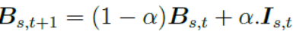 (2.7)
where  is a constant whose value ranges between 0 and 1. With this simple background model, pixels corresponding to foreground moving objects can be detected by thresholding any of those distance functions:
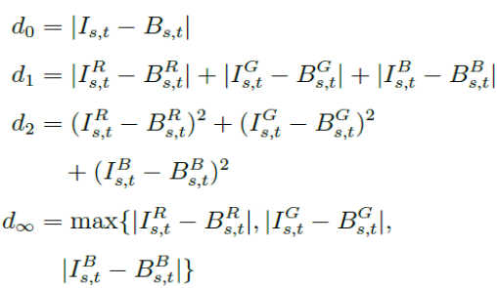 (2.8)
where R,G and B stand for the red, green and blue channels and d₀ is a measure operating on grayscale images. It is also possible to use the previous frame I_{t}−1 as background image. With this configuration though, motion detection becomes an inter-frame change detection process which is robust to illumination changes but suffers from a severe aperture problem since only parts of the moving objects are detected.

2.3 Video Object Segmentation

The different methods currently available for object segmentation in videos is explored below.
2.3.1 Interactive or supervised methods
Several methods for video object segmentation require the user to manually annotate a few frames with object segmentations and then propagate these annotations to all other frames [3, 20, 26].Similarly, methods based on tracking [8, 24], require the user to mark the object positions in the first frame and then track them in the rest of the video.
2.3.2. Background subtraction
Classic background subtraction methods model the appearance of the background at each pixel and consider pixels that change rapidly to be foreground. These methods typically assume a stationary, or slowly panning camera [9, 4, 7]. The background should change slowly in order for the model to update safely without generating false-positive foreground detections.
2.3.4. Clustering point tracks
Several automatic video segmentation methods track points over several frames and then cluster the resulting tracks based on pairwise [6, 17]or triplet [18] similarity measures. The underlying assumption induced by pairwise clustering [6, 17] is that all object points move according to a single translation, while the triplet model [18] assumes a single similarity transformation. These assumptions have trouble accommodating non-rigid or articulated objects. Our method instead does not wish to cluster object points and does not assume any kind of motion homogeneity. The object only needs to move sufficiently differently from the background to generate motion boundaries along most of its physical boundary. On the other hand, these methods [6, 17, 18] try to place multiple objects in separate segments, whereas our method produces a simpler binary segmentation (all objects vs background).

2.3.5. Ranking object proposals
The works [14, 16, 27] are closely related to ours, as they tackle the very same task. These methods are based on finding recurring object-like segments, aided by recent techniques for measuring generic object appearance [10], and achieve impressive results on the SegTrack benchmark [24]. While the object proposal infrastructure is necessary to find out which image regions are objects vs background, it makes these methods very slow(minutes/frame). In our work instead, this goal is achieved by a much simpler, faster process. Our method achieves comparable segmentation accuracy to [14] while being two orders of magnitude faster.
2.3.6. Over-segmentation
Grundmann et al. [13] over-segment a video into spatio-temporal regions of uniform motion and appearance, analog to still-image superpixels [15]. While this is a useful basis for later processing, it does not solve the video object segmentation task on its own.
2.4 Object Recognition

2.4.1 Bag of words
In Bag of Words model features are extracted using detectors or dense sampling and descriptors are calculated at each and every local feature extracted. The features extracted from the images should be easily detected under changes in pose, illumination and should be distinctive. There should be many features per object. After feature extraction, features are hard clustered by data clustering technique like K-means. After clustering a visual vocabulary is obtained with predefined number of visual words. In training phase, the input vectors from the feature pool are assigned to one or more classes. The decision rule divides input space into decision regions separated by decision boundaries and histogram is built up. In testing phase, for the test data point, the k closest points from training data is found and classification is done using KNN classifier.
2.4.2 Feature Extraction
Features are generally a random collection of points in an image or it may be a collection of distinctive points in an image like blobs and corners which are likely to be repeatable. For local feature detection, classic detectors include Harris detector and its extension, maximally stable external region detector, affine invariant salient region detector. For local feature description, local descriptors such as scale-invariant feature transform (SIFT) descriptor, shape context, histogram of gradients (HOG) descriptor and speeded up robust feature descriptor (SURF) etc are usually used. In this work Harris detector with SIFT (128 D) descriptor is used.
2.4.3 SIFT descriptor using Harris detector
The major stages in computations include four steps. (1) Identifying key points (Harris detector) (2) key point localisation (3) orientation assignment (4) key point descriptor computation (SIFT).
The Harris detector is a scale, rotation, and translation invariant interest point detection algorithm that has also shown to be robust to illumination variations, camera noise and viewpoint changes. Harris detector is based on the second moment matrix.The second moment matrix given in equation (1), also called the auto-correlation matrix, defined for each pointp is often used for feature detection or for describing local image structure.
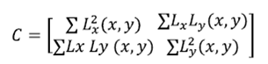 (2.9)
Here, L_{x} and L_{y} denote the respective x and y gradient magnitude images, and the summation is taken over all points in a neighbourhood of point p. The matrix C can be seen as a covariance matrix of the Gradient magnitude within a neighbourhood. It is real and symmetric, and so it can be decomposed into its principal components, with Eigen values λ1 and λ2.Harris noted the following in regions of constant intensity, λ1= λ2= 0.In regions with very little intensity variation, both λ1and λ2 will be small. For an edge region, the variation in one direction will be strong, and the variation in the other direction will be weak. Therefore, λ1 will be large, and λ2will be small. For a corner region, there will be strong variations in both directions and so both λ1and λ2 will exceed some threshold value.
Key point localisation attempts to remove unstable key points from the final list by finding those that are poorly localised on a corner. Orientation assignment aims to assign a consistent orientation to the key points based on local image properties. The key point descriptor can then be represented relative to this orientation, achieving invariance to rotation. The gradient magnitude, m, orientation(x,y) are given by the equations (2) and (3).
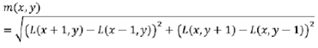 (2.10)
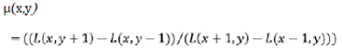 (2.11)
Further the local image gradients are measured in the region around each key point. These are transformed into a representation that allows for significant levels of local shape distortion and change in illumination. The local gradient data is also used to create key point descriptors. The gradient information is rotated to line up with the orientation of the key point. These data are then used to create a set of histograms over a window centered on the key point. Key point descriptors typically use a set of 16 histograms, aligned in a 4×4 grid, each with 8 orientation bins, one for each of the main compass directions and one for each of the midpoints of these directions. This process results in a feature vector, containing 128 elements.
2.4.4 Clustering
Clustering is the process of assigning a set of objects into groups so that the objects of similar type will be in one cluster. Clustering can be classified as hard clustering and soft clustering. Hard clustering and soft clustering differ in assigning the value to the partition matrix. Hard clustering assigns the value of either 0 or 1 whereas soft clustering allows the value to be in more than one cluster. The object will be assigned to a cluster that has the highest value. The general algorithms available for hard clustering are K-means and K-medoid . In this work hard clustering algorithms like K-means and K-medoid algorithms are used for clustering with Euclidean measure as distance metric learning. In our project, we have used K-means algorithm.
A. K means Algorithm
K-meansis one of the simplest unsupervised algorithm that partition extracted features 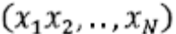from images into k number of clusters. Given an image set X, initial random cluster centers are chosen.
B. Steps for K means Algorithm
The procedure follows in a simple way
- Compute the distance D_{ik}² between each data point x_{k} and cluster centers v_{i}..
(2.12)
- Select the points for the cluster, with minimal distances, they belong that cluster.
- Recalculate the cluster centers v_{i}, by finding the mean of the data points x_{i} of corresponding clusters.
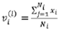 (2.13)
Until
(2.14)
- Repeat the process until k distinct clusters are obtained.

2.4.5 Classifier
The k-nearest neighbour algorithm (k-NN) is a method for classifying objects based on closest training examples in the feature space. The k-nearest neighbour algorithm is amongst the simplest of all machine learning algorithms. An object is classified by a majority vote of its neighbours where k is a positive integer, typically small. If k= 1, then the object is simply assigned to class of its nearest neighbour. The nearest-neighbour method is perhaps the simplest of all algorithms for predicting the class of a test example. The training phase is simple, that is to store every training example, with its label. To make a prediction for a test example, first compute its distance to every training example. Then, keep the k closest training examples, where k ≥ 1 is a fixed integer. This basic method is called the k-NN algorithm. The most common distance function is Euclidean distance neighbours (k is a positive integer, typically small). If k= 1, then
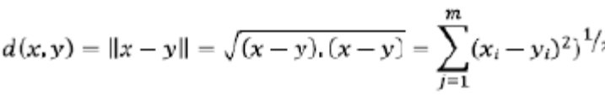 (2.15)
K-Nearest Neighbour algorithm (KNN) is a part of supervised learning that has been used in many applications in the field of data mining, statistical pattern recognition and many others. KNN is a method for classifying objects based on closest training examples in the feature vector. An object is classified by a majority vote of its neighbours. K is always a positive integer. The neighbours are taken from a set of objects for which the correct classification is known. It is usual to use the Euclidean distance, though other distance measures such as the Manhattan distance can be used.
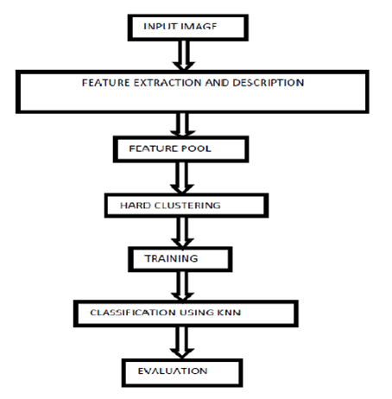
Figure 2.2 Bag of Visual Words Algorithm
An object recognition system finds objects in the real world from an image of the world, using object models which are known a priori. This task is surprisingly difficult. Humans perform object recognition effortlessly and instantaneously. Algorithmic description of this task for implementation on machines has been very difficult. Here we have discussed the different types of recognition tasks.
2.4.6 System Component
An object recognition system must have the following components to perform the task:
- Model database (also called model base)
- Feature detector
- Hypothesizer
- Hypothesis verifier
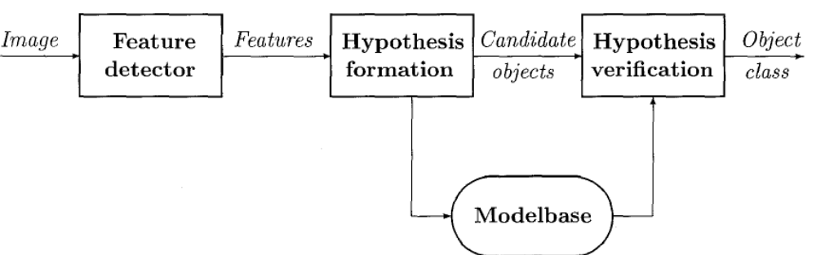
Figure 2.3 Different components of an object recognition system
The model database contains all the models known to the system. The feature detector applies operators to images and identifies locations of features that help in forming object hypotheses. Using the detected features in the image, the hypothesizer assigns likelihoods to objects present in the scene. The verifier then uses object models to verify the hypotheses and refines the likelihood of objects. The system then selects the object with the highest likelihood, based on all the evidence, as the correct object.
2.5 Object Representation
Images represent a scene from a camera's perspective. It appears natural to represent objects in a camera-centric, or viewer-centered, coordinate system. Another possibility is to represent objects in an object-centered coordinate system. Of course, one may represent objects in a world coordinate system also.
A representation allows certain operations to be efficient at the cost of other operations. Representations for object recognition are no exception. Designers must consider the parameters in their design problems to select the best representation for the task. The following are commonly used representations in object recognition.
2.5.1 Observer-Centered Representations
If objects usually appear in a relatively few stable positions with respect to the camera, then they can be represented efficiently in an observer-centered coordinate system. If a camera is located at a fixed position and objects move such that they present only some aspects to the camera, then one can represent objects based on only those views. If the objects in a domain of applications are significantly different from each other, then observer-centered representations may be enough. Observer-centered representations are defined in image space. These representations capture characteristics and details of the images of objects in their relative camera positions.
2.5.2 Object-Centered Representations
An object-centered representation uses description of objects in a coordinate system attached to objects. This description is usually based on three dimensional features or description of objects. Object-centered representations are independent of the camera parameters and location. Thus, to make them useful for object recognition, the representation should have enough information to produce object images or object features in images for a known camera and viewpoint. This requirement suggests that object-centered representations should capture aspects of the geometry of objects explicitly.
2.6 Feature Detection
Many types of features are used for object recognition. Most features are based on either regions or boundaries in an image. Some of the commonly used features are as follows
2.6.1 Global Features
Global features usually are some characteristics of regions in images such as area (size), perimeter, Fourier descriptors, and moments. Global features can be obtained either for a region by considering all points within a region, or only for those points on the boundary of a region. In each case, the intent is to find descriptors that are obtained by considering all points, their locations, intensity characteristics, and spatial relations.

2.6.2 Local Features
Local features are usually on the boundary of an object or represent a distinguishable small area of a region. Curvature and related properties are commonly used as local features. The curvature may be the curvature on a boundary or may be computed on a surface. The surface may be an intensity surface or a surface in 2.5-dimensional space. High curvature points are commonly called corners and play an important role in object recognition. Local features can contain a specific shape of a small boundary segment or a surface patch. Some commonly used local features are curvature, boundary segments, and corners.
2.6.3 Relational Features
Relational features are based on the relative positions of different entities, either regions, closed contours, or local features. These features usually include distance between features and relative orientation measurements. These features are very useful in defining composite objects using many regions or local features in images. In most cases, the relative position of entities is what defines objects. The exact same feature, in slightly different relationships, may represent entirely different objects.

2.7 Recognition Strategies
a few basic recognition strategies used for recognizing objects in different situations are discussed below
2.7.1 Classification
The basic idea in classification is to recognize objects based on features. Pattern recognition approaches fall in this category, and their potential has been demonstrated in many applications. Neural net-based approaches also fall in this class. All techniques in this class assume that N features have been detected in images and that these features have been normalized so that they can be represented in the same metric space. some of the techniques to normalize these features after classification are:
- Nearest Neighbor Classifiers
- Bayesian Classifier
- Off-Line Computations
- Neural Nets
2.7.2 Matching
These approaches consider each model in sequence and fit the model to image data to determine the similarity of the model to the image component. This is usually done after the segmentation has been done. Some of the basic matching approaches are discussed below.

2.7.3 Feature Matching
Suppose that each object class is represented by its features. As above, let us assume that the jth feature's value for the ith class is denoted by iij. For an unknown object the features are denoted by Uj. The similarity of the object with the ith class is given by
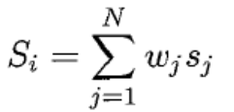 (2.16)
where Wj is the weight for the jth feature. The weight is selected based on the relative importance of the feature. The similarity value of the jth feature is Sj. This could be the absolute difference, normalized difference, or any other distance measure. The most common method is to use
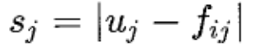 (2.17)
and to account for normalization in the weight used with the feature.
The object is labeled as belonging to class k if Sk is the highest similarity value. Note that in this approach, we use features that may be local or global.
2.7.4 Symbolic Matching
An object could be represented not only by its features but also by the relations among features. The relations among features may be spatial or some other type. An object in such cases may be represented as a graph. Each node of the graph represents a feature, and arcs connecting nodes represent relations among the objects. The object recognition problem then is considered as a graph matching problem.
A graph matching problem can be defined as follows. Given two graphs G1 and G2 containing nodes Nij , where i and j denote the graph number and the node number, respectively, the relations among nodes j and k is represented by Rijk. Define a similarity measure for the graphs that considers the similarities of all nodes and functions.
In most applications of machine vision, objects to be recognized may be partially visible. A recognition system must recognize objects from their partial views. Recognition techniques that use global features and must have all features present are not suitable in these applications. In a way, the partial view object recognition problem is similar to the graph embedding problem studied in graph theory. The problem in object recognition becomes different when we start considering the similarity of nodes and relations among them.

Chapter 3
SYSTEM DESIGN
3.1 Architecture Design
Obtain the corrected video
Compare the test images with the database images
Compute edge difference and calculate threshold
Store keyframes in ‘test’
Train the database images
Compute the histogram for database images

Compute the histogram for test images (keyframes)

Input video
Video
stabilization
Filter the key frames

Recognize car and bike
Extract consecutive frames
Audio output

Figure 3.1 Architecture diagram
3.2 Video Stabilization
A moving camera may either be attached to a vehicle or may be handheld. Videos captured from handheld cameras are very jittery. Those attached to vehicles may also undergo jitter and sudden changes. It is highly undesirable to work with such video frames since it is tedious to differentiate between the foreground and the background. Hence stabilizing the video before further processing becomes a necessity.
Usually videos are stabilized by tracking a prominent feature that is common to all the frames and using it as an anchor point to cancel out all disturbances relative to it. But to implement such a method, we are required to know the position of the prominent feature in the first frame. We employ a method of video stabilization which does not require such presumptive knowledge, but rather uses a method of point feature matching which is capable of automatically searching for the background plane in a video sequence and using its observed distortion to correct for camera motion.
The basic idea of the proposed stabilization algorithm is to first determine the affine image transformations between all neighbouring frames of the video by using a Random Sampling and Consensus (RANSAC) procedure [3] applied to point correspondences between two images. Then the video frames are warped to achieve a stabilized video.
The algorithm consists of the following steps. Initially we read the first two video frames, say frame A and frame B. They are read as intensity images (since colour is not necessary and also because using grayscale images improves speed) and points of interest from both frames are collected, preferably the corner points of all objects in the frame. Then we extract features for each set of points and find likely correspondences between both the set of points. The matching cost used between the points is the sum of the squared differences (SSD) between their respective image regions. Since we do not apply any uniqueness constraint, points from frame B can correspond to multiple points in frame A. To get rid of incorrect correspondences and to obtain only the valid inliers, we make use of the RANSAC algorithm. Next we find the affine transform between the points of frame A and frame B. It is a 3-by-3 matrix of the form:
a₁ a₃ t_{r}
a₂ a₄ t_{c} (3.1)
0 0 1

This transform can be used to warp all the succeeding frames such that their corresponding features will be moved to the same image location. The cumulative distortion of a frame relative to the first frame will be the product of all the preceding inter-frame transforms.
For numerical simplicity, we re-fit the above affine transform into a simpler scale-rotation-translation transform, which has only four free parameters: one scale factor, one angle, and two translations. This s-r-t transform matrix is of the form:

s*cos(θ) s*-sin(θ) t_{x}
s*sin(θ) s*cos(θ) t_{y} (3.2)
0 0 1

The above steps are iteratively applied to all the video frames, hence resulting in smooth and stabilized video sequence.
3.3. Video object segmentation
Since background subtraction on its own does not produce accurate results, we propose to employ object segmentation techniques as a preceding step. We hope this will result in better object detection and recognition results.
Video object segmentation separates the foreground objects from the background in a video. Usually several methods for video object segmentation require the user to manually annotate a few frames with object segmentations and then propagate these annotations to all other frames. Several other automatic video segmentation methods track points over several frames and then cluster the resulting tracks based on pair wise or triplet similarity measures. Such methods assume motion homogeneity.
The method which we propose to use is assumed to be computationally efficient, fully automatic, and makes minimal assumptions about the video. This enables us in handling certain unconstrained settings, such as rapidly moving background, arbitrary object motion and appearance, and non-rigid deformations and articulations. The only requirement for this method is that the object should move differently from its surrounding background in a good fraction of the video. The object can be static in a portion of the video and only part of it can be moving in some other portion. Also, the object need not follow a particular motion model.
The proposed method has two main stages:
(i) efficient initial foreground estimation
(ii) foreground-background labelling refinement
3.3.1 Efficient Initial Foreground Estimation
The goal of the first stage is to rapidly produce an initial estimate of which pixels might be inside the object based purely on motion. We compute the optical flow between pairs of subsequent frames and detect motion boundaries. Ideally, the motion boundaries will form a complete closed curve coinciding with the object boundaries. However, due to inaccuracies in the flow estimation, the motion boundaries are typically incomplete and do not align perfectly with object boundaries(Figure3.2f). Also, occasionally false positive boundaries might be detected. To robustly determine which pixels reside inside the moving object, we make use of inside-outside maps. These steps are explained in further detail
below.

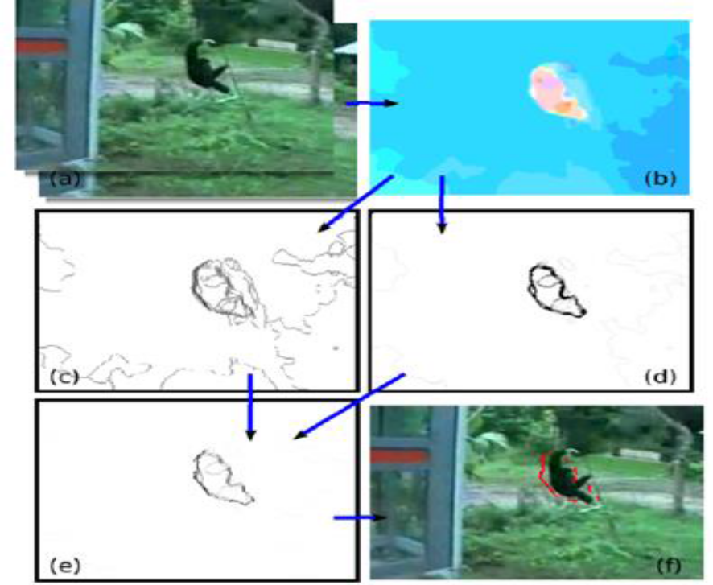
Figure 3.2. Optical flow and motion boundaries. (a) Two input frames. (b) Optical flow fp. The hue of a pixel indicates its direction and the colour saturation its velocity. (c) Motion boundaries bmp , based on the magnitude of the gradient of the optical flow. (d) Motion boundaries bθp ,based on difference in direction between a pixel and its neighbours. (e) Combined motion boundaries bp (f) Final binary motion boundaries after thresholding, overlaid on the first frame.

3.3.1.1. Optical Flow
We begin by computing optical flow between pairs of subsequent frames (t , t + 1) using the state-of-the-art algorithm ‘large displacement optical flow’ technique. In this technique, first a region hierarchy is established for both images. Descriptor matching on these regions provides a sparse set of hypotheses for correspondences. These are integrated into a variational approach and these guide the local optimization to large displacement solutions. The variational optimization selects among the hypotheses and provides dense and subpixel accurate estimates, making use of geometric constraints and all available image information.
3.3.1.2 Motion Boundaries
Let fp be the optical flow vector at pixel p. Next we estimate the motion boundaries by computing the magnitude of the gradient of the optical flow field as follows
b^{m}_{p} = 1 – exp( -λ^{m} || Δf_{p}|| ) (3.3)
where bmp ϵ [0,1] is the strength of the motion boundary at pixel p; λ^{m} is a parameter controlling the steepness of the function. While this measure correctly detects boundaries at rapidly moving pixels, where bmp is close to 1, it is unreliable for pixels with intermediate bmp values around 0.5, which could be explained either as boundaries or errors due to inaccuracies in the optical flow (figure 3.3c). To disambiguate between those two cases, we compute a second estimator b^{θ}_{p} ϵ [0,1], based on the difference in direction between the motion of pixel p and its neighbours N
b^{θ}_{p} = 1 - exp( -λ^{θ} max_{qϵN} ( δθ²_{p,q} ) ) (3.4)
where δθ_{p,q} denotes the angle between f_{p} and f_{q.} The idea is that if n is moving in a different direction than all its neighbours, it is likely to be a motion boundary. This estimator can correctly detect boundaries even when the object is moving at a modest velocity, as long as it goes in a different direction than the background.
However, it tends to produce false-positives in static image regions, as the direction of the optical flow is noisy at points with little or no motion.
As the two measures above have complementary failure modes, we combine them into a measure that is more reliable than either alone( figure 1e)
b_{p} = b^{m}_{p} if b^{m}_{p} > T
b^{m}_{p} .b^{θ}_{p} if b^{m}_{p} < T (3.5)

where T is a high threshold, above which b^{m}_{p} is considered reliable on its own. As a last step we threshold b_{p} at 0.5 to produce a binary motion boundary labelling.

3.3.1.3. Inside-outside maps
The produced motion boundaries typically do not completely cover the whole object boundary. Moreover, there might be false positive boundaries, due to inaccuracy of the optical flow estimation. Hence, we make use of inside outside maps to accurately determine whether a pixel is inside an object or not.
The core concept of inside-outside maps is as follows. Any ray starting from a point inside a polygon (or any closed curve) will intersect the boundary of the polygon an odd number of times. Instead, a ray starting from a point outside the polygon will intersect it an even number of times(Figure 3.2a).
Since the motion boundaries are typically incomplete, a single ray is not sufficient to determine whether a pixel lies inside the object. Instead, we get a robust estimate by shooting 8 rays spaced by 45 degrees. Each ray casts a vote on whether the pixel is inside or outside. The final inside-outside decision is taken by majority rule, i.e. a pixel with 5 or more rays intersecting the boundaries an odd number of times is deemed inside.

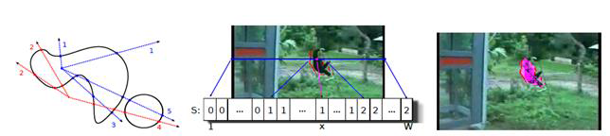Figure 3.3. Inside-outside maps. (Left) The ray casting observation. Any ray originating inside a closed curve intersects it an odd number of times. Any ray originating outside intersects it an even number of times. This holds for any number of closed curves in the image. (Middle) Illustration of the integral intersections data structure S for the horizontal direction. The number of intersections for the ray going from pixel x to the left border can be easily computed as Xleft(x,y) = S(x-1,y) = 1, and for the right ray as Xright(x,y) = S(W,y) – S(x,y) = 1. In this case, both rays vote for x being inside the object. (Right) The output of inside-outside map Mt.

3.3.2. Foreground-Background Labelling Refinement
As they are purely based on motion boundaries, the inside-outside maps produced by the first stage only approximately indicate where the object is. They do not accurately delineate object outlines. Furthermore, (parts of) the object might be static in some frames, or the inside-outside maps may miss it due to incorrect optical flow estimation. The goal of the second stage is to refine the spatial accuracy of the inside-outside maps and to segment the whole object in all frames. To achieve this, it integrates the information from the inside-outside maps over all frames by (i) encouraging the spatio-temporal smoothness of the output segmentation over the whole video and (ii) building dynamic appearance models of the object and background under the assumption that they change smoothly over time. Incorporating appearance cues is the key to achieving a finer level of detail, compared to using only motion. The detailed process is as follows.
First we over segment each frame into super pixels St, which greatly reduces computational efficiency and memory usage, enabling to segment much longer videos. Each super pixel s^{t}_{i} ϵ St can take a label l^{t}_{i} ϵ {0,1}. A labelling L = { l^{t}_{i} }_{t,i} of all super pixels in all frames represents a segmentation of the video. We define an energy function [4,5,6] to evaluate a labelling as follows:
E(L) = Σ_{t,i} A^{t}_{i} (l^{t}_{i} ) + α₁ Σ_{t,i} A^{t}_{i} (l^{t}_{i} ) + α₂ Σ_{(i,j,t)ϵ E} V^{t}_{ij} ( l^{t}_{i} , l^{t}_{j} ) + α₃ Σ_{(i,j,t)ϵ E} W^{t}_{ij} ( l^{t}_{i} , l^{t+1}_{j} ) (3.6)
At is a unary potential evaluating how likely a super pixel is to be foreground or background according to the appearance model of frame t. The second unary potential Lt is based on a location prior model encouraging foreground labellings in areas where independent motion has been observed. We derive both the appearance model and the location prior parameters from the inside-outside maps Mt. The pair wise potentials V and W encourage spatial and temporal smoothness, respectively. The scalars α weight the various terms. The output segmentation is the labeling that minimizes the following:
L* = argmin E(L) (3.7)

3.3.2.1. Smoothness V, W
The spatial smoothness potential V is defined over the edge set Es, containing pairs of spatially connected super pixels. Two super pixels are spatially connected if they are in the same frame and are adjacent. The temporal smoothness potential W is defined over the edge set Et, containing pairs of temporally connected super pixels. Two super pixels s^{t}_{i} , s^{t+1}_{i} in subsequent frames are connected if there is at least one pixel in s^{t}_{i} that moves into s^{t+1}_{i} according to the optical flow.

3.3.2.2 Appearance Model AT
The appearance model consists of two Gaussian Mixture Models over RGB colour values, one for the foreground (fg) and one for the background (bg). The appearance model parameters are estimated automatically based on the inside-outside maps Mt.

3.3.2.3 Location Model LT
When based only on appearance, the segmentation could be distracted by background regions with similar colour to the foreground. Fortunately, the inside-outside maps can provide a valuable location prior to anchor the segmentation
to image areas likely to contain the object, as they move differently from the surrounding region. However, in some frames (part of) the object may be static, and in others the inside-outside map might miss it because of incorrect optical flow estimation (fig. 3.4, middle row).
Therefore, we propagate the per-frame inside-outside maps over time to build a more complete location prior Lt. The algorithm accumulates inside points over the entire video sequence, following the optical flow (fig. 3.4, bottom row).

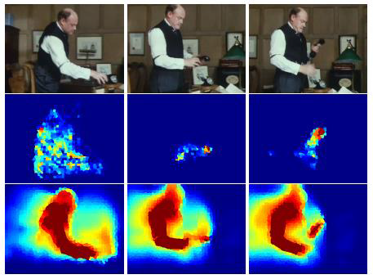

Figure 3.4. Location model. Top row: three video frames. Middle row: likelihood of foreground based on the inside-outside maps in individual frames. They miss large parts of the person in the second and third frames, as the head and torso are not moving. Bottom row: the location model based on propagating the inside-outside maps. It includes most of the person in all frames.

3.3. The Affine Camera Model
Image distortions coming from viewpoint changes can be modeled by affine planar transforms. Any affine map A is defined:
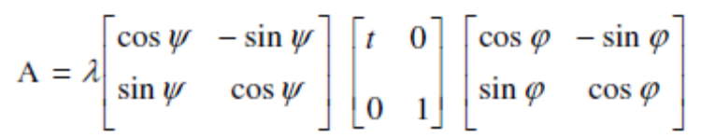 (3.8)
Which we note A = R1()Tt R2(), where > 0,_{t} is the determinant of A, R_{i} are rotations, [0,180), and T_{t} is a tilt namely a diagonal matrix with first eigen value t > 1 and the second one equal to 1. Figure 3.5, shows a camera motion interpretation. and= arccos 1/ t are respectively the camera optical axis longitude and latitude, corresponds to the zoom and a third angle parameterizes the camera spin.

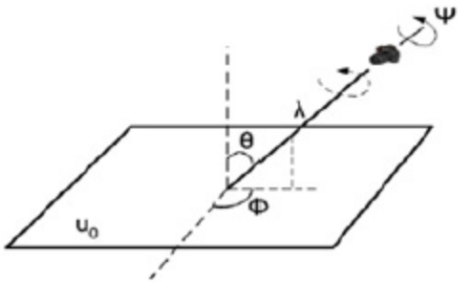
Figure 3.5. Camera motion interpretation
3.3.1. Scale Space Extremum Detection
The next step is extracting key points that are invariant to changes of scale. We need to search for stable features in all possible changes. In previous research it has been shown that for this task, the Gaussian function is the only possible scale-space kernel. A function, L(x,y,), is the scalespace of an image that is obtained from the convolution of an input image, I(x,y), with a variable scale-space Gaussian function, G(x,y,). For efficiently detecting stable keypoint locations, Lowe proposed using the scale-space extremum in difference-of-Gaussian (DOG) function, D(x,y,). Extremum computed by the difference of two nearby scales separated by a constant factor K(2): 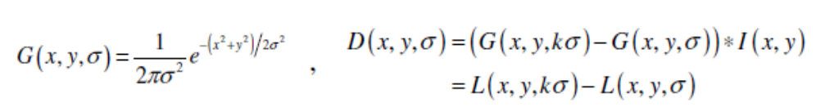(3.9)
This process repeats in several octaves. In each octave, the initial image is repeatedly convolved with Gaussians to produce the set of scale space images. Adjacent Gaussian images are subtracted to produce the difference-of-Gaussian images. After each octave, the Gaussian images are down sampled by a factor of 2, and the process repeated. Figure 3.6, shows a visual representation from this process.
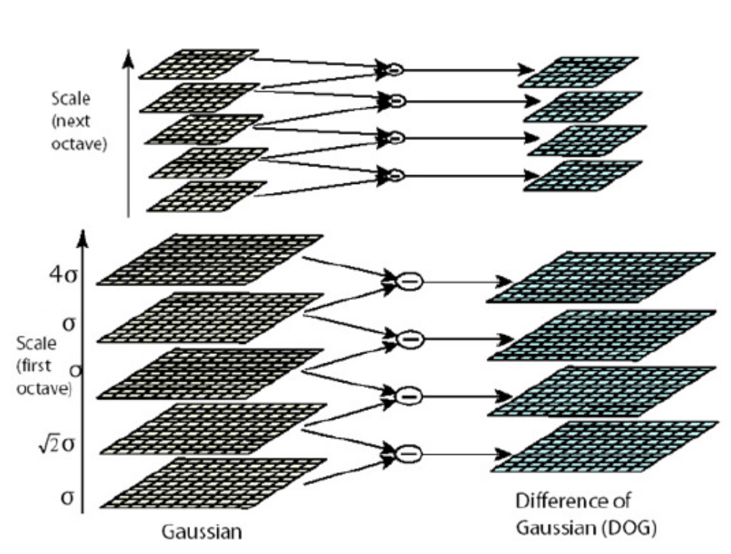
Figure 3.6. Visual representation of DOG in octaves

Each sample point (pixel) is compared with its neighbors according to their intensities for finding out whether it is smaller or larger than its neighbors. For more accuracy, each pixel will be checked with the eight closest neighbors in an image location and nine neighbors in the scale above and below (Figure 3.6). If the point is an extremum against all 26 neighbors, it is selected as candidate keypoint. The cost of this comparison is reasonably low because most sample points will be eliminated in first few checks.
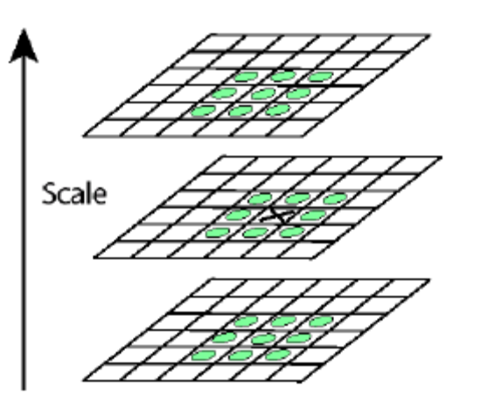
Figure 3.7. Local extremum detection of DOG
3.3.2 Accurate Key point Localization
For each candidate keypoint interpolation of nearby data is used to accurately determine its position. Then, many key points that are unstable and sensitive to noise, like the points with low contrast and the points on the edge, will be eliminated.

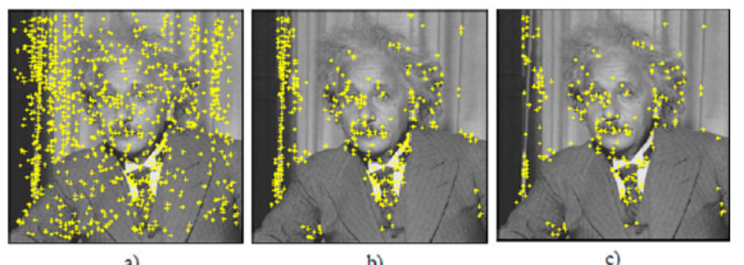
Figure 3.8. (a) Extremum of DOG across scales. (b) Remaining keypoints after removal of low contrast points. (c) Remaining keypoints after removal of edge responses.

3.3.3 Assigning an Orientation
The next step is assigning an orientation for each keypoint. By this step, the keypoint descriptor can be represented relative to this orientation and therefore get invariance to image rotation. For each Gaussian smoothed image sample, points in regions around keypoint are selected and magnitude, m, and orientations, , of gradiant are calculated.
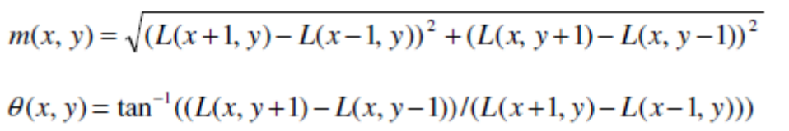 (3.10)
Then, created weighted (magnitude + gaussian) histogram of local gradiant directions is computed at selected scale. A histogram is formed by quantizing the orientations into 36 bins by covering 360 degree range of orientations. The highest peak in the histogram is detected where peaks in the orientation histogram correspond to dominant directions of local gradiant.

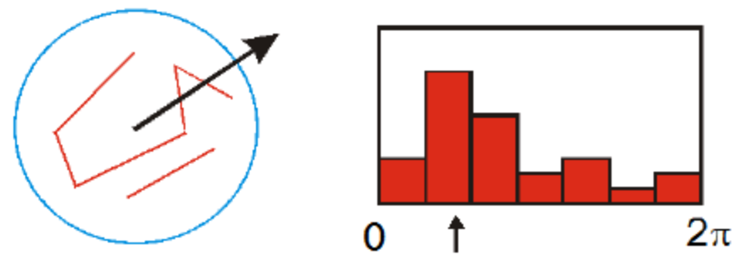
Figure 3.9. Visual representation of orientation histogram. (the histogram is shown in 7 bins)
3.3.4. Key point Descriptor
The previous operations have assigned location, scale, and orientation to each keypoint and provided invariance to these parameters. Remaining goals are to define a keypoint descriptor for the local image regions and reduce the effects of illumination changes. The descriptor is based on 16×16 samples that the keypoint is in the center of. Samples are divided into 4×4 sub regions in 8 directions around keypoint. Magnitude of each point is weighted and gives less weight to gradients far from keypoint (Figure3.10). Therefore, feature vector dimensional is 128 (4×4×8).
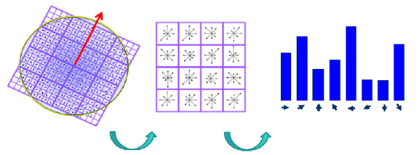
Figure 3.10.Keypoint Descriptor
Finally, vector normalization is applied. The vector is normalized to unit length. A change in image contrast in which each pixel value is multiplied by a constant will multiply gradients by the same constant. Contrast change will be canceled by vector normalization and brightness change in which a constant is added to each image pixel will not affect the gradient values, as they are computed from pixel differences. Now we can find key points from an image in the other images and match them together.
3.4 K-Means Clustering
K-means is one of the simplest algorithms that solve the Clustering problem. The procedure follows a simple and easy way to classify a given data set through a certain number of clusters (assume k clusters) fixed a priori. The main idea is to define k centroids, one for each cluster. These centroids should be placed in a cunning way because different location causes different result. So, the better choice is to place them as far away as possible from each other. The next step is to take each point belonging to a given data set and associate it to the nearest centroid. When no point is pending, the first step is completed and an early groupage is done. At this point we need to re-calculate k new centroids as the centers of the clusters resulting from the previous step. After we have these k new centroids, a new binding has to be done between the same data set points and the nearest new centroid. A loop has been generated. As a result of this loop we may notice that the k centroids change their location step by step until no more changes are done. In other words centroids do not move any more. Finally, this algorithm aims at minimizing an objective function, in this case a squared error function. The objective function
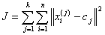 , (3.11)
where 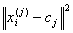 is a chosen distance measure between a data point and the cluster centre , is an indicator of the distance of the n data points from their respective cluster centres.
The algorithm is composed of the following steps:
- Place K points into the space represented by the objects that are being clustered. These points represent initial group centroids.
- Assign each object to the group that has the closest centroid.
- When all objects have been assigned, recalculate the positions of the K centroids.
- Repeat Steps 2 and 3 until the centroids no longer move. This produces a separation of the objects into groups from which the metric to be minimized can be calculated.
Although it can be proved that the procedure will always terminate, the k-means algorithm does not necessarily find the most optimal configuration, corresponding to the global objective function minimum. The algorithm is also significantly sensitive to the initial randomly selected cluster centres. The k-means algorithm can be run multiple times to reduce this effect.
3.4. Implementation of Bag of Features
Bag of Features is one of the successful object classification techniques which is
used for the process of object recognition. Our main task here is to classify a
given image in to one of the pre-determined objects. Object Recognition using
BOF works on the principal that every object can be represented by its parts .Let’s
say a Bike contains parts like wheels, handles etc which all combine to form an
object called Bike. Also Car also contains wheels which defines a car, but the
basic difference between a Bike and Car is it’s handles and some other parts
which distinguishes car from bike. So, in order to recognize an object we need to
first recognize the parts and based on the parts we need to classify the object. This
is the principal behind Object Recognition using BOF.
The Object Recognition using the bag of features is described as follows.
1) Extract features
2) Learn “visual vocabulary”
3) Quantize features using visual vocabulary
4) Represent images by frequencies of “visual words”
In this project, we have implemented the Object Recognition using BOF using
MATLAB. The next sections will much discuss about the implementation details
of above four steps.
3.4.1. Algorithm
(i) Extracting Features
Let us consider image of the car as an example. In order to describe the parts
of an car, we need to automatically find the parts of the car in the image. So,
in the Algorithm we first use Harris corner detector. By doing so, we get
corners in the image, but in order to define car we need parts, so in order to
describe a part we take 6 pixel radius around corners and use SIFT feature
(128 dimension vector) to describe the part. We can use SIFT, SURF and
some other features to describe the structure of parts. So, we described the
parts of an aeroplane using SIFT feature vectors.

(ii) Learn “Visual Vocabulary”
Now, we need to form a dictionary of parts which contain parts of each
and every object. So, we will setup a task to train our dictionary. We will
form a dictionary by taking different objects and also different images of
same object (in different angles).
Now, repeat step (i) for each and every image during training and store 128
dimension vector (for SIFT) for every corner detector in the image in to an array.
So, a large matrix will be formed. Using this matrix, clustering is done among the
data. There are many types of clustering techniques.(in this project kmeans
clustering is used). Now, we can visualize each cluster center as a representation
of part. So, we have a dictionary which contains different parts and they are
represented as cluster centers.
(iii) Quantize Features using Visual Vocabulary and Represent Images by Frequencies of “Visual Words”
So, now we have a dictionary which contains descriptions of the parts and
are categorized. But, in order to represent an object, the system needs to
know which part belongs to which i.e. for e.g. the basic difference between
the car and bikes is that, the car contains 4 wheels while bikes contain 2
wheels. So, from this we can infer that the frequency of occurrence of part
describes an object. So, now we have to train our system in order to make
it understand the frequency of parts in an object. Here the step 1 and find
SIFT features for an object (image) is repeated. The nearest parts matching
these SIFT features is found. So every SIFT feature is categorized into one
of the part based on the distance from SIFT feature to the cluster centers.
A histogram for all cluster centers on x-axis and frequency on y-axis,
which represents the frequency of parts is formed. Every image can now

be represented with a histogram which shows the frequency of parts.
Every Histogram can be viewed as a point in the higher dimension space.

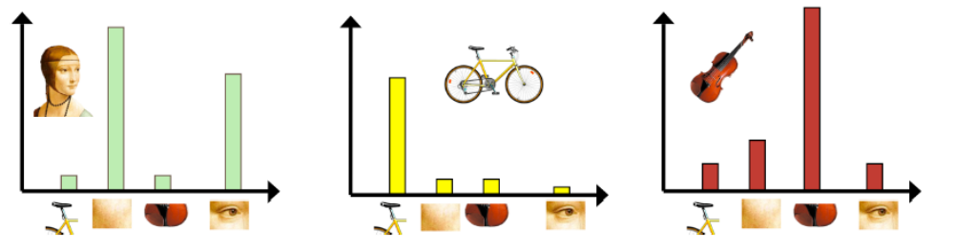
Figure.3.11 Histogram representation of objects

Training
During training we use a set of 50 cars+50 bikes. We follow step 1, 2 and 3 and
project all the histograms in to higher dimension space. So, every point in the
higher dimension space represents an object. In the theoretical case all the points
in higher dimension space of similar objects should be close together.
Testing
Step 1, 2 and 3 are repeated on the remaining images of database and K-nearest
neighborhood search is done in order to find closet object that matches the test
object. Evaluation of our algorithm is done using confusion matrix.
Evalution
For evaluation purpose, run evaluation and we will get two arrays cars, bikes. If
the number in the cars array (or bikes) is less than 3 it is considered as
misclassified. Else it is considered as classified.

Chapter 4

IMPLEMENTATION

4.1 Video Stabilization Intermediate Results

To show that the error of converting the affine transform to s-r-t transform is minimal, we re-project frame B with both transforms as shown below.

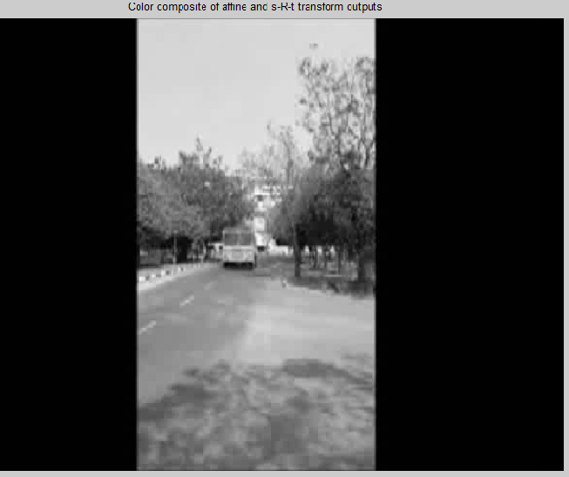

Figure 4.1.Transform Approximation

During computation, we computed the mean of the raw video frames and of the corrected frames. These mean values are shown side-by-side below. The left image shows the mean of the raw input frames, proving that there was a great deal of distortion in the original video. The mean of the corrected frames on the right, however, shows the image core with almost no distortion. While foreground details have been blurred (as a necessary result of the camera motion), this shows the efficacy of the stabilization algorithm.

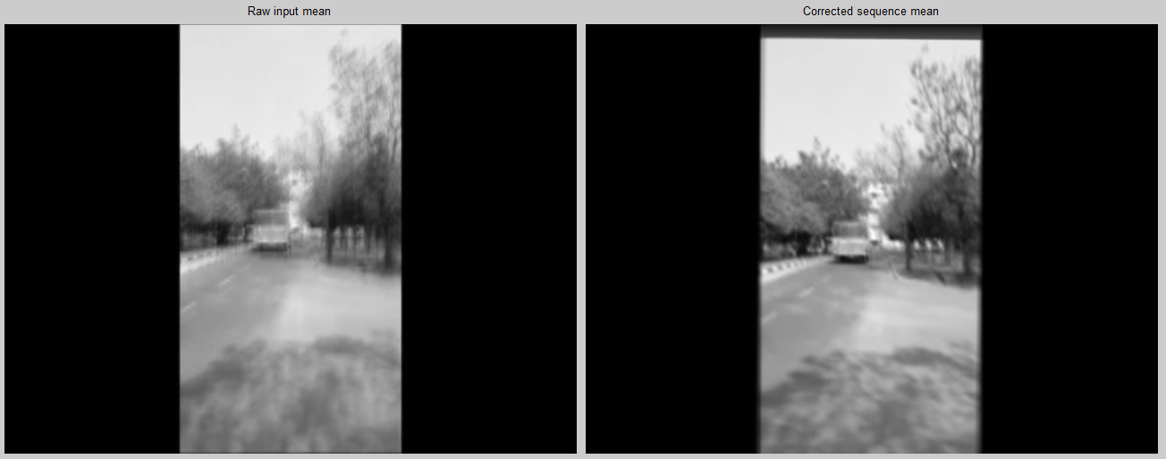

Figure 4.2.Mean of all video frames for raw video and corrected video

4.2 Key Frame Extraction Output
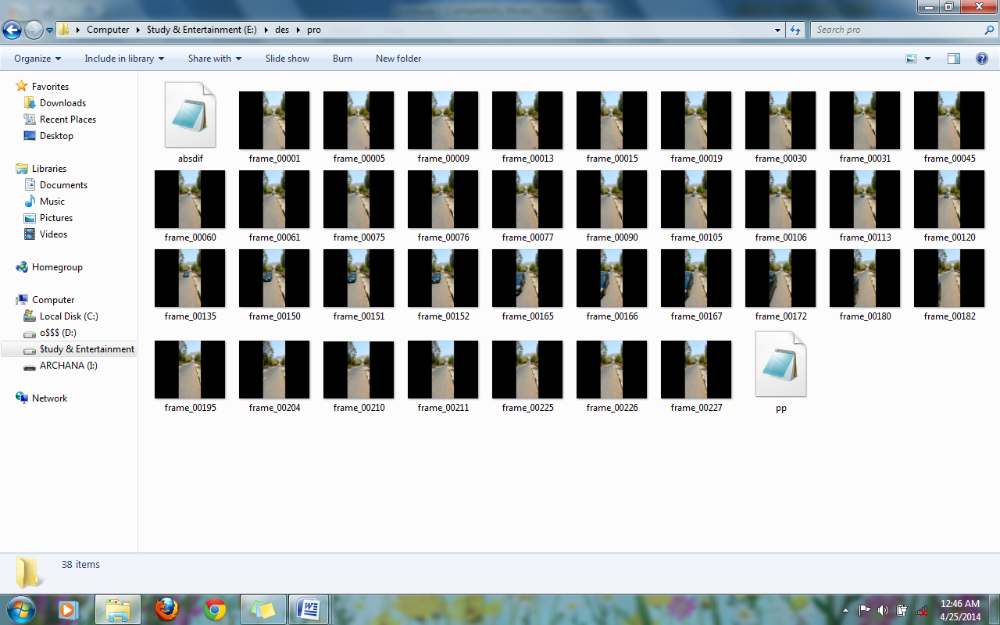

Figure 4.3 Total key frames extracted

4.3. Segmentation output

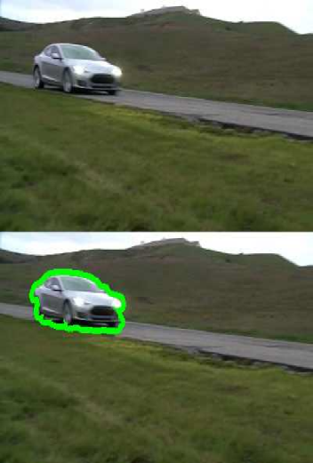
Figure 4.4. Segmentation output

4.4 Object Recognition
The message box which is displayed when the object is recognized(shown here is the recognition of car and bike).

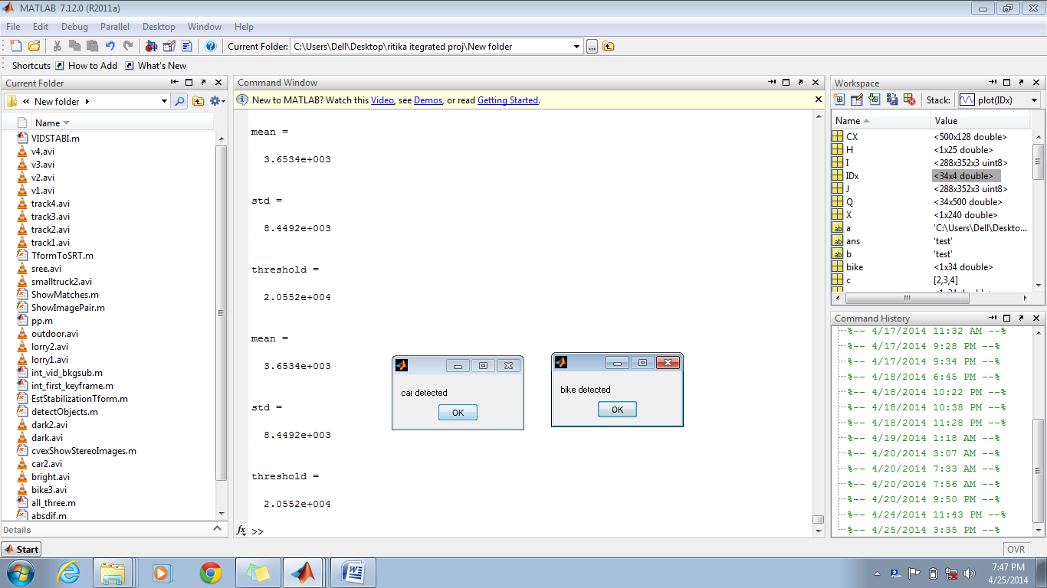

Figure 4.5.Recognition of car and bike

Database containing images of car from different views which are trained.
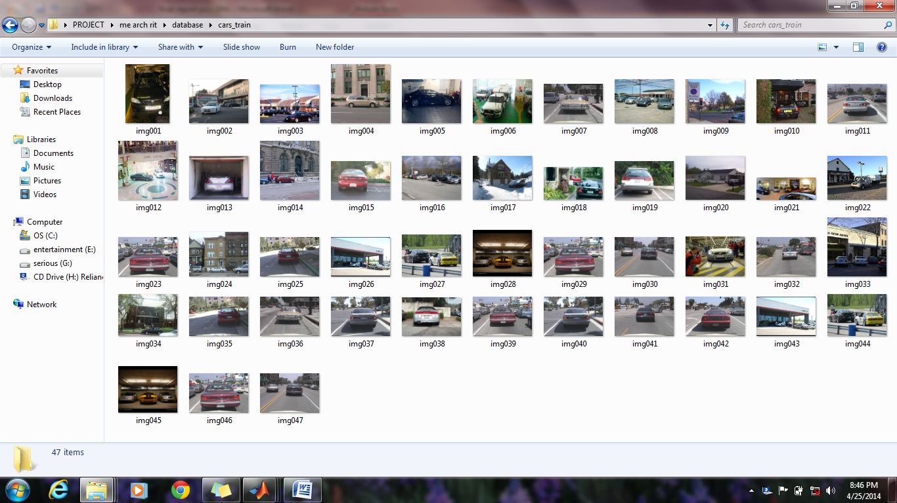
Figure 4.6 Database of car

Database containing images of bike from different views which are trained.


Figure 4.7 Database of bikes

Chapter 5
CONCLUSION
Our proposed system is a step towards aiding visually impaired people in obstacle recognition enabling them to make more confident and informed movements. A small portable camera can be attached to the clothing of the blind man. This camera captures video frames which will serve as the input to the system. The blind man receives output audio signals via headphones.
Complex outdoor scenes, camera jitter and moving obstacles have all been considered. For each module of our work, we have selected the best existing algorithms and techniques. Recognition has been performed for two sets of obstacles i.e., car and bike. The same can be extended to work for any other object. The accuracy of the result is around 60-70%.
The run time of the project is slightly high. As a future work the project can be made faster. Also, video object segmentation can be integrated into the system to get more accurate recognition results.

REFERENCES

[1] Gerard Medioni and Sing Bing Kang, Emerging topics in computer vision, Prentice Hall, 2004.
[2] Gottipati Srinivas Babu, “Moving object detection using Matlab”, IJERT, vol. 1, issue 6, August 2012.
[3] Marco Zuliani, RANSAC for Dummies, August 2012.
[4] Byeong-Ho Kang, “A review on image and video processing”, vol. 2, International Journal of Multimedia and Ubiquitous Engineering, April 2007.
[5] Khushboo Khurana and Dr. M. B. Chandak, “Key frame extraction methodology for video annotation, IJCET, vol. 4, issue 2, March-April 2013, pp. 221-228.
[6] C.F.Lam, M.c.Lee,”Video segmentation using colour difference histogram”, Lecture Notes in Computer Science, New York: Springer Press, pp.159-174, 1998.
[7] D. Borth, A. Ulges, C. Schulze, T. M. Breuel, “Key frame Extraction for Video Tagging & Summarization”, volume S-6 of LNI, page 45-48, 2008.
[8] D. Hari Hara Santosh, P. Venkatesh, P. Poornesh, L. Narayana Rao, N. Arun Kumar,” Tracking Multiple Moving Objects Using Gaussian Mixture Model”, International Journal of Soft Computing and Engineering (IJSCE) ISSN: 2231-2307, Volume-3, Issue-2, May 2013.
[9] Hitesh A Patel1, Darshak G Thakore2, “Moving Object Tracking Using Kalman Filter”,IJCSMC, Vol. 2, Issue. 4, April 2013, pg.326 – 332.
[10] HHerv´e J´egou, Matthijs Douze, and Cordelia Schmid. Improving bag-of-features for large
scale image search. International Journal of Computer Vision, 87(3):316–336, 2010.
[11] Yu-Gang Jiang, Chong-Wah Ngo, and Jun Yang. Towards optimal bag-of-features for object categorization and semantic video retrieval. In CIVR, pages 494–501, 2007. [12] Chris Harris and Mike Stephens, A Combined Corner and Edge Detector, Proceedings of The Fourth Alvey Vision Conference (Manchester, UK), pp. 147-151, 1988.

[13] David G. Lowe. Distinctive image features from scale-invariant keypoints. International Journal Of Computer Vision, 60(2):91–110, 2004.
[14] David G. Lowe. Object recognition from local scale-invariant features. In ICCV, pages 1150– 1157, 1999.
[15] Khaled Alsabti , Sanjay Ranka, Vineet Singh, “An Efficient K-Means Clustering Algorithm”.
[16] E. Hadjidemertriou, M. Grossberg,and S. Nayar. Multi resolution histograms and their use in recognition. IEEE Trans. PAMI, 26(7):831-847, 2004
PUBLICATION

"Recognition and tracking of moving objects using moving camera in complex scenes" in International Journal of Computer Science Engineering and Applications (IJCSEA), April 2014, Volume 4, Number 2.

